
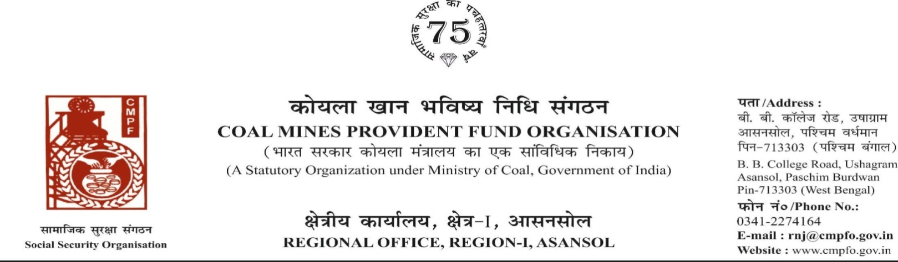
Ref. : CPF/118/Misc/RNJ/LC/OUT/R-I/ASN/ Date : 15/07/2025

To,
The Regional Commissioner-I,
Coal Mines Provident Fund Organisation,
Sreepat Road, Sub P.O. SECL,
Bilaspur, Chhatisgarh- 495006

Sub:- Inter Regional Transfer of Ledger Card, DA, PS -3 & 4.
Ref:-ECL/SBP/GM/(OP)/PERS/CMPS/25/P-79 Date : 08/07/2025
Sir,
In view of the revised Procedures prescribed in Procedure Office Order No-35 Dated-12.02.1975 of CMPF Commissioner,Dhanbad, I am to state that the Ledger Cards of the following members along with Declaration in Form "A" Form-I (Pen),PS-3 & 4 may kindly be forwarded to this office as the member(s) is /are working in this region.
It may kindly be ensured that the posting in the Ledger Cards may be made updated for the periods the member was working in your Region.
SL. No | Name of the Member | CMPF A/C No | Name of the colliery where the member is currently working in | Name of the colliery where the member had earlier worked in | Name of the Company | Period of Posting
1 | Sri DAYA RAM MEGHWAL | BLP/23/334 | SONEPUR BAZARI PROJECT  (RNJ/34) | CMPDI Camp  ( Kudumkela ) | CMPDI  ( Bilaspur ) | Sept-2008  TO  Aug-2017
 |  |  |  | GAREPALMA-4/2&3  ( Raigarh Area ) | SECL | Sept-2017  TO  June-2022

In light of this, we kindly request you to do the needful action and kindly arrange the transfer of his ledger card from previous working zones and update the records accordingly.
Thank you for your attention to this matter.
Encl. : As above Posting Details ( One copy )

Yours faithfully

Assistant Commissioner

